After seeing Josephine’s email, I double checked the data to make sure I included data from 1974 to 1975. I noticed I only have 10-15 entries each for 1974 and 1975. Although the data for each line is correct, I realised I am missing a lot of data due to a parameter issue in my access query when removing null first winter survivals (n=567).

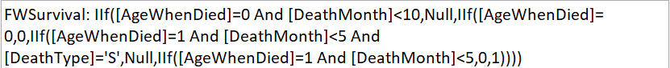

Since AgeWhenDied is also a new term I created in the same query it caused some issues if I try to remove null in the same query. I have now removed the null first winter survivals in a separate query and it seems to work fine with 1770 more entries (n=2337).

With the new data set, hind models are the only ones where density is significant and they also have the lowest AIC values.

Winter yeld is now significant in all models, so is Mum Age squared and sex. Birth weight is significant in models that included it, and for models that excluded birth weight, mum age is significant as well.

With the current data set, scaling the numeric variables doesn’t seem to make any difference too.

**Summary**

**Yellow = insignificant**

|  | **glmmTMB** | **glmmTMB**  **Scaled** | **glmmTMB**  **No Birthwt** | **glmmTMB**  **No Birthwt**  **Scaled** |
| --- | --- | --- | --- | --- |
| **Hinds** | **-0.016 (p=0.029)** | **-0.36 (p=0.029)** | **-0.016 (p=0.023)** | **-0.36 (p=0.023)** |
| **Adults** | **-0.0042 (p=0.44)** | **-0.14 (p=0.44)** | **-0.0042 (p=0.42)** | **-0.14 (p=0.42)** |
| **Total** | **-0.0022 (p=0.66)** | **-0.078 (p=0.66)** | **-0.0021 (p=0.66)** | **-0.075 (p=0.66)** |
| **Livestock Units** | **-0.0034 (p=0.81)** | **-0.043 (p=0.81)** | **-0.0033 (p=0.81)** | **-0.041 (p=0.81)** |

**AIC**

|  | **glmmTMB** | **glmmTMB**  **Scaled** | **glmmTMB**  **No Birthwt** | **glmmTMB**  **No Birthwt**  **Scaled** |
| --- | --- | --- | --- | --- |
| **Hinds** | **2369.9** | **2369.9** | **2521.8** | **2521.8** |
| **Adults** | **2374.0** | **2374.0** | **2526.3** | **2526.3** |
| **Total** | **2374.4** | **2374.4** | **2526.8** | **2526.8** |
| **Livestock Units** | **2374.6** | **2374.6** | **2526.9** | **2526.9** |

**Hinds**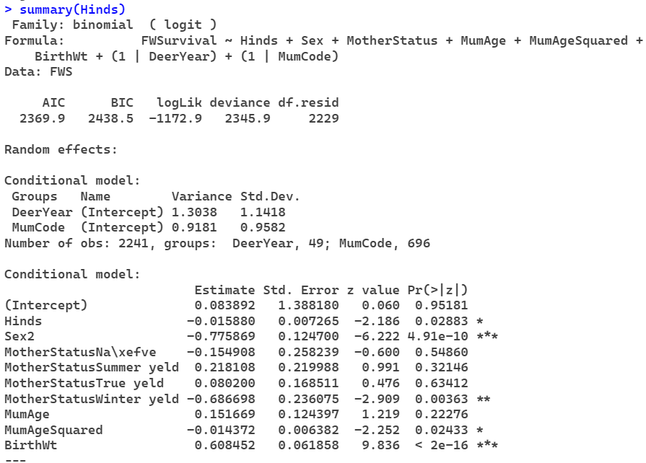

**Adults**

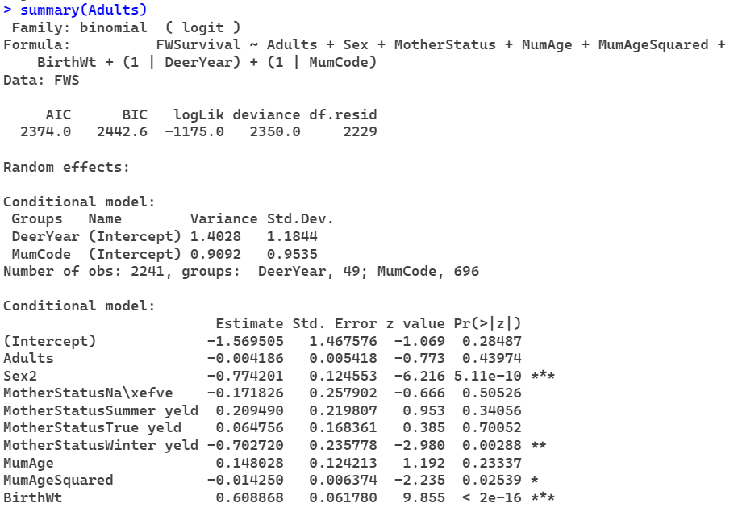

**Total**

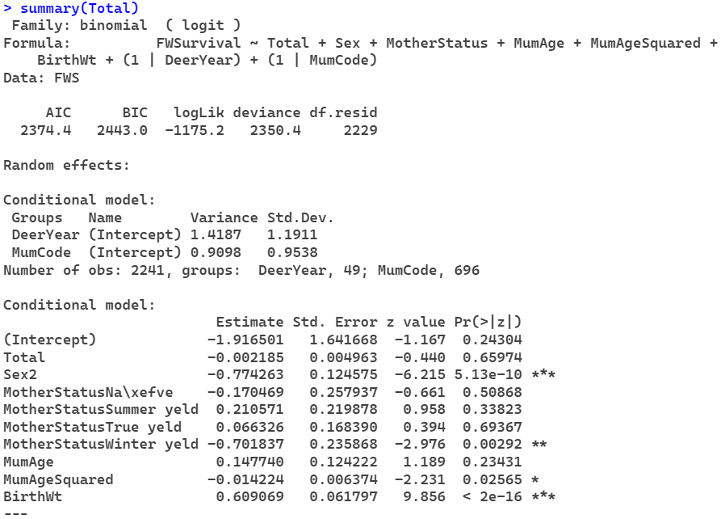

**Livestock Units**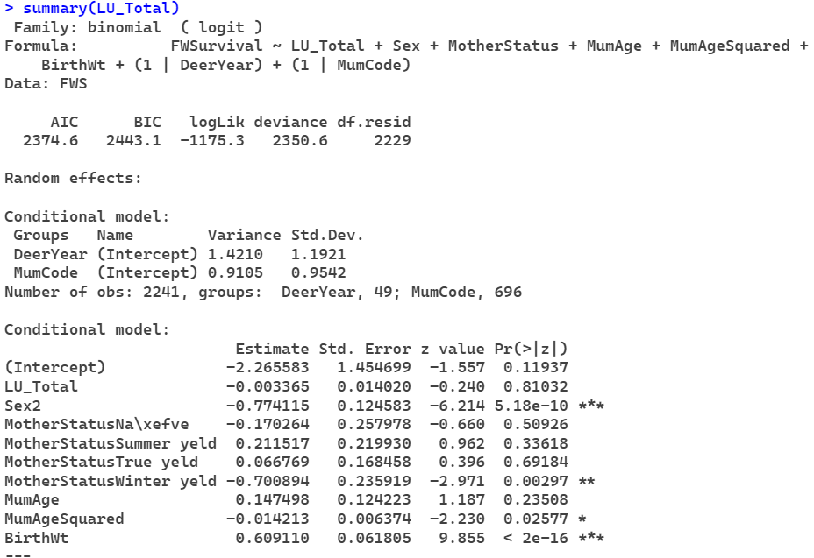

**Scaled Hinds**

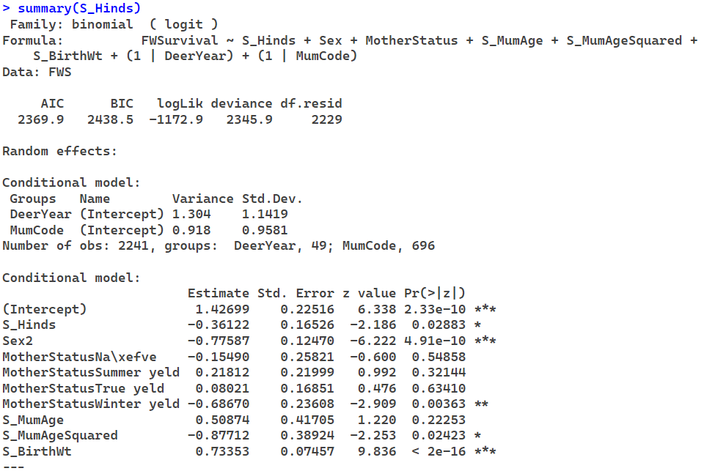

**Scaled Adults**

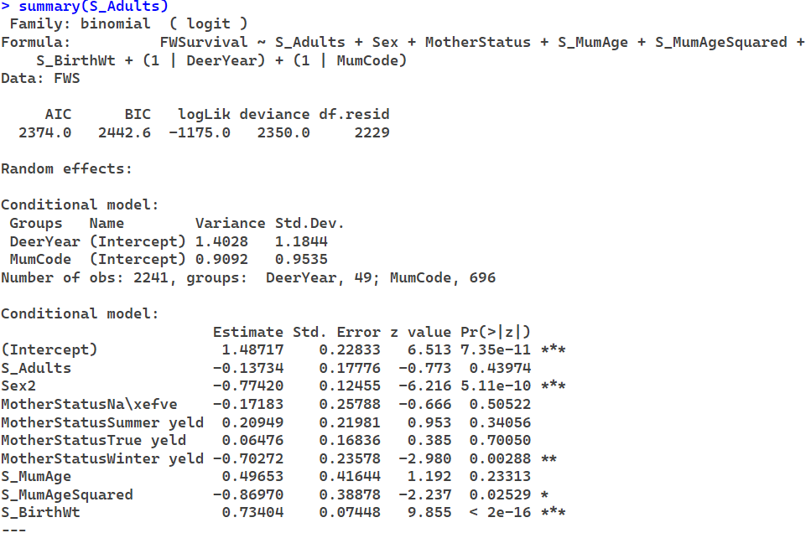

**Scaled Total**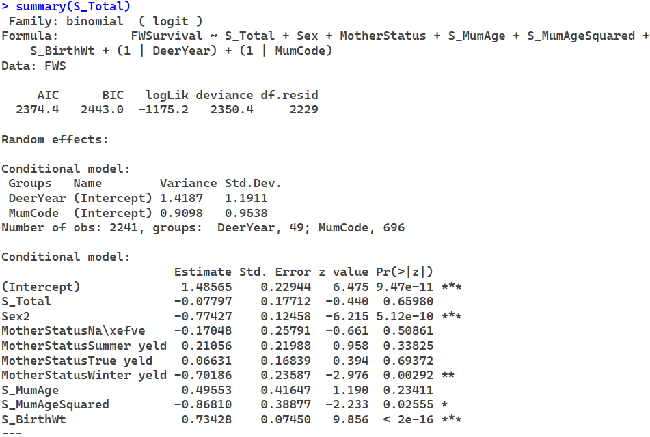

**Scaled Livestock Units**

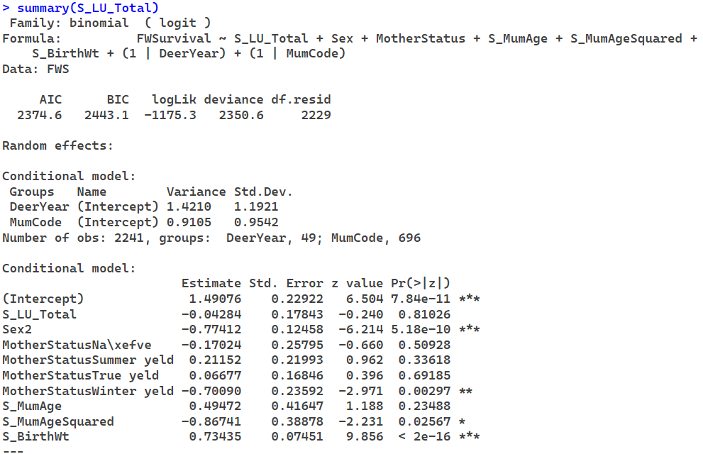

**Hinds w/o birth weight**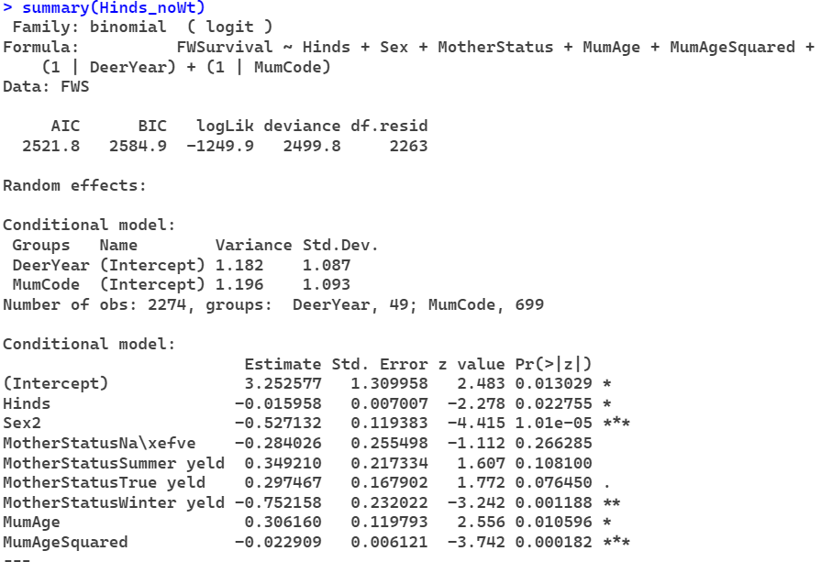

**Adults w/o birth weight**

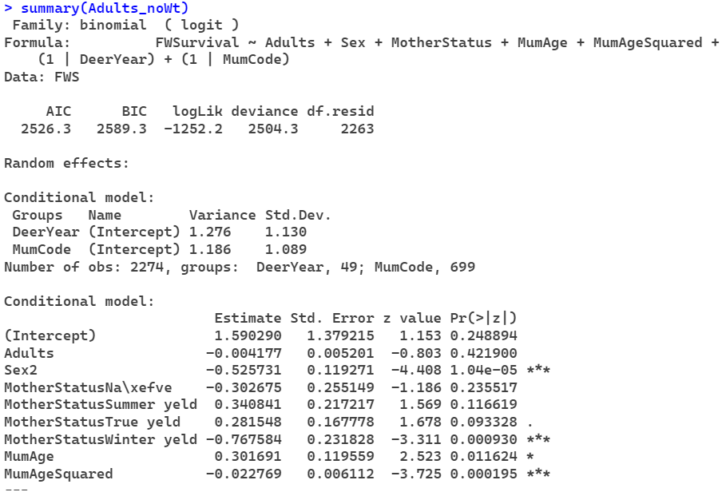

**Total w/o birth weight**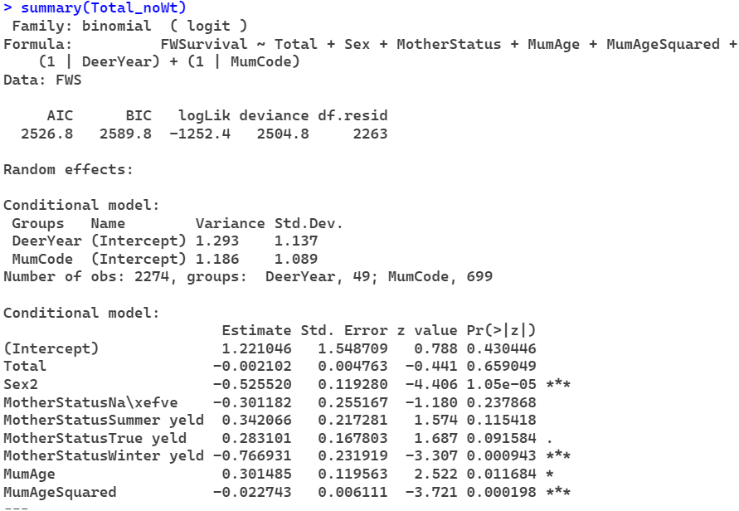

**Livestock Units w/o birth weight**

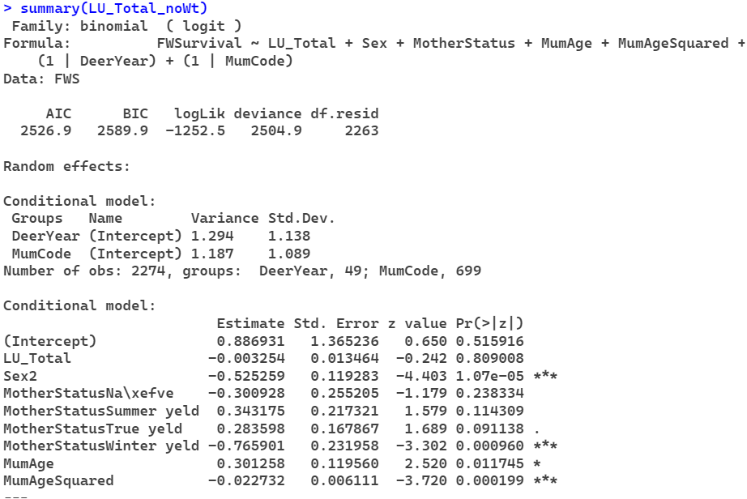

**Scaled Hinds w/o birth weight**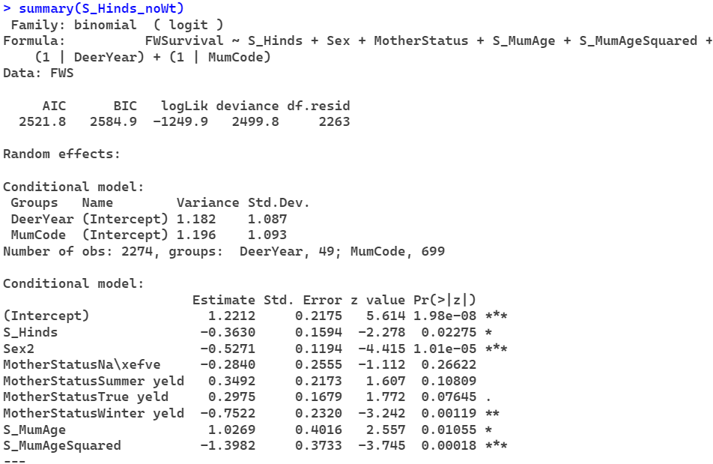

**Scaled Adults w/o birth weight**

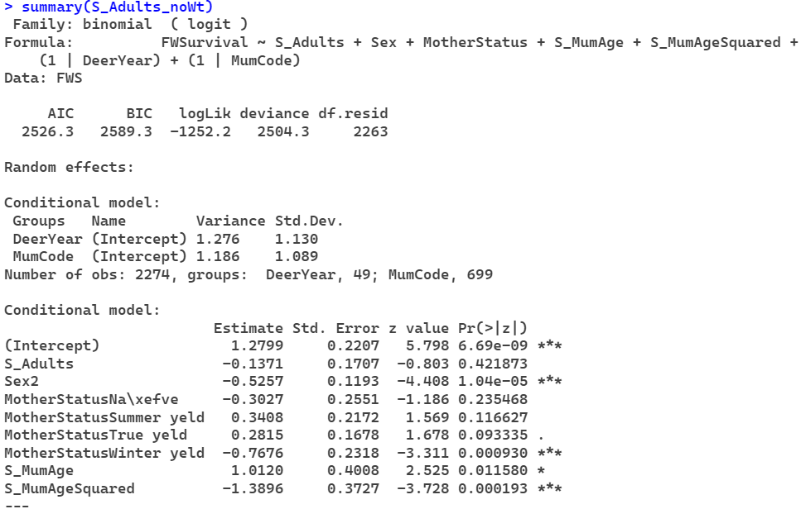

**Scaled Total w/o birth weight**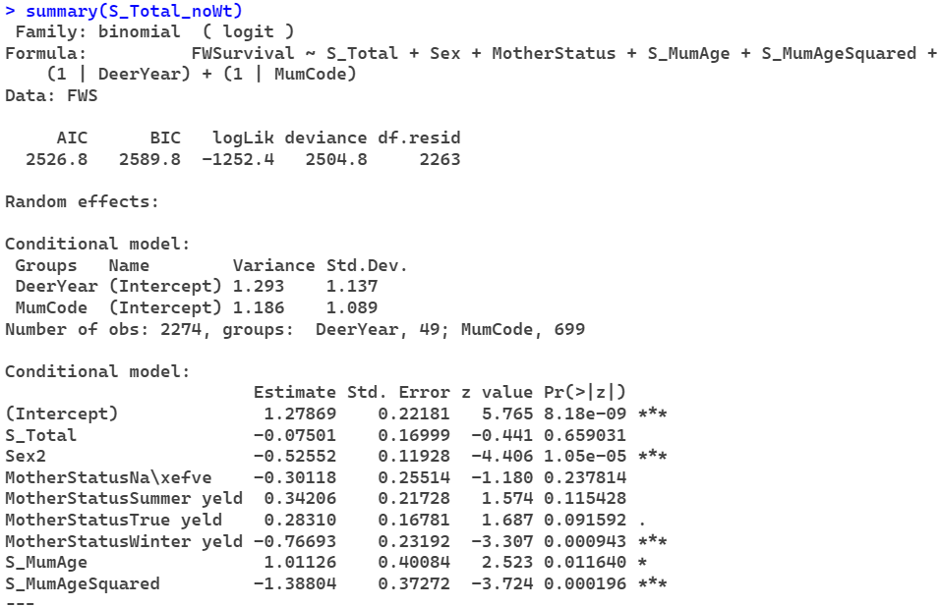

**Scaled Livestock Units w/o birth weight**

